**Mission Statement**

The website is intended to promote beach volleyball as a family activity while appealing to a younger audience of between 15 and 30 years. Other social activities which are offered need to be highlighted such as a licensed bar and a capability for organising functions. The goal of the website is to increase the customer base of Slammers Beach Volleyball by 50%.

**Success Evaluation**

An increase of the number of players at Slammers Beach Volleyball by 50% while appealing to people aged between 15 and 30 years would show the website has served its purpose. A 50% improvement equates to an additional 50 players per week. All the additional 50 players is to fall into the age bracket 15 and 30 years. Lastly, a 25% increase of revenue from the bar takings will show that the website has successfully promoted this aspect of Slammers.

**Target Audience**

The site is intended for:

1. Families interested in playing sport.
2. People aged between 15 and 30 interested in team sport.
3. People who are looking for a place to socialise.

The site design will make provisions for the above groups by:

1. Using images of families and people within the target age group playing volleyball as well as images of people socializing
2. The use of an underlying theme of having fun, being happy, socailising, meeting new friends and playing team sport.
3. Ensuring there is cohesion with good navigation while using scannable text.

**Site Flow Chart**

Inserted to HTML

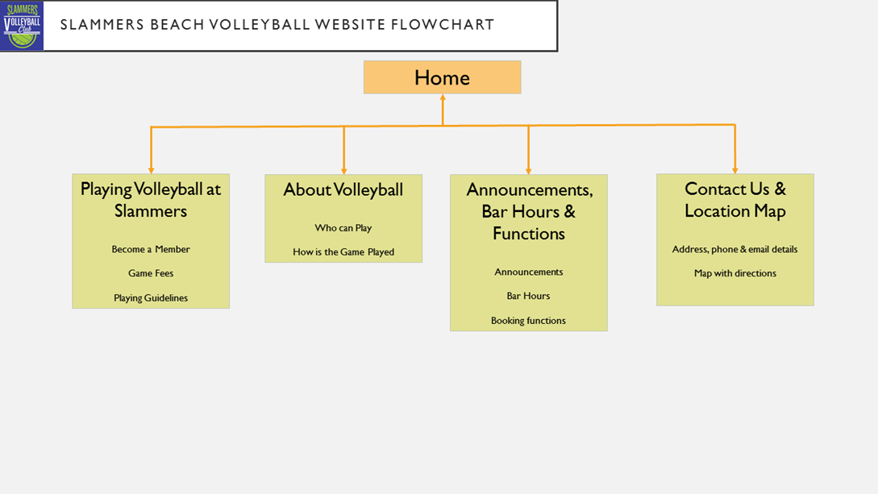

**Website Lifecycle Development**

Inserted to HTM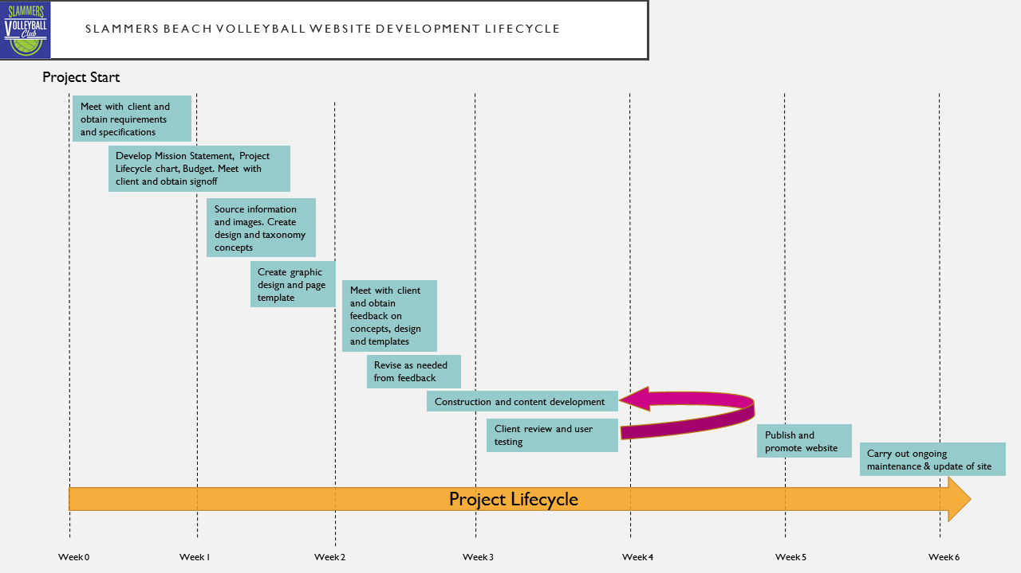

**Home Page (Name – Index.html)**

Home Playing Volleyball About Volleyball Announcements, Bar Hours & Functions Contact Us & Location Map

**Welcome to Slammers Beach Volleyball Club**

**The Health Club With it All**

We are passionate about beach volleyball. Playing the game promotes health, fitness and is one of the only team sports which can be played by people of all ages. At Slammers you can play volleyball as a family, competitively or just for having fun with friends. Next time at the beach drop in and check us out.

Our premium playing facilities are complimented with other services such as a licensed bar which serves healthy meals. Also, if you are looking for a venue for a function we have just the place.

**Did you know Slammers was voted “Cairnsvilles BEST Club Sports Facility”!**

**Playing Volleyball Page**

Home Playing Volleyball About Volleyball Announcements, Bar Hours & Functions Contact Us & Location Map

We organise volleyball games to cater for all people. We provide the ball, sandy volleyball court, umpire and scoreboard. There are volleyball competitions run throughout the year as follows:

* Family volleyball (six a side – families)
* 15 to 17 years (boys, girls & mixed 6 or 2 a side)
* Under 18’s (boys, girls & mixed 6 or 2 a side)
* 19 to 25 years (men, women & mixed 6 or 2 a side)
* 26 to 35 years (men, women & mixed 6 or 2 a side)
* 36 to 45 years (men, women & mixed 6 or 2 a side)
* 46 to 55 years (men, women & mixed 6 or 2 a side)
* 56+ (men, women & mixed 6 or 2 a side)

At Slammers we cater for school, social, fitness and sport groups who want to play the game.

**As part of the training regime for the Cairnsville Cowboys they play at Slammers every week. Paul Brown (Cowboys Coach) says “Slammers provides first class facilities. Volleyball is used by the Cowboys to improve dexterity, hand/eye coordination and team work”.**

Register your team online by filling in your details and we will be in touch with you shortly

I have read and agree to the Player Guidelines below

Contact Persons Name (first name & surname)

Competition Time (choose afternoon or evening)

Competition Day (choose between Monday & Saturday)

Email Address

**Playing Guidelines**

Phone Number

Participants in Slammers Beach Volleyball play at their own risk. Anyone playing is responsible for their own safety and should only play if they are capable. Check with your doctor before you begin.

Game fees must be paid prior to the start of the game. Games may be cancelled by players up to 4 hours before hand to get a refund. Without 4 hours' notice, participants will forfeit the game and be charged 50% of the game fee.

**Send**

**About Volleyball Page**

Home Playing Volleyball About Volleyball Announcements, Bar Hours & Functions Contact Us & Location Map

Volleyball is a team sport played by two teams on a playing court divided by a net. The sport originated in the United States, and is now just achieving the type of popularity in the U.S. that it has received on a global basis, where it ranks behind only soccer among participation sports. There are 800 million players worldwide who play Volleyball at least once a week.

The object of the game is:

* for each team to send the ball regularly over the net to ground it on the opponent's court and to prevent the ball from being grounded on its own court.
* The ball is put into play by the right back-row player who serves the ball by hitting it over the net to the opponent's court.
* A team is allowed to hit the ball three times (in addition to the block contact) to return it to the opponent's court. A player is not allowed to hit the ball twice consecutively, except when attempting a block. The rally continues until the ball touches the ground/floor, goes "out" or a team fails to return it to the opponent's court or commits a fault.
* The team winning a rally scores a point (Rally Point System). When the receiving team wins a rally, it gains a point and the right to serve, and its players rotate one position clockwise.
* The best of three or best of five games will win matches. Each non-deciding game will be won by the team that first scores 25 points with a minimum two-point advantage (no scoring cap).
* If there is a deciding game, it will be won by the team that first scores 15 points with a minimum two-point advantage (no scoring cap).

Reproduced from http://www.volleyball.org/whatis.html

**Did you know:**

* **The court is 60 feet long and 30 feet wide.**
* **There is a net that divides the court in half.**
* **For Men's volleyball, the regulation net height is 7 feet, 11 5/8 inches.**
* **For Women's volleyball, the regulation net height is 7 feet, 4 1/4 inches high.**

**At Slammers we provide referees for all games. Did you know our referees are fully accredited by Volleyball Australia and Queensland? Volleyball Australia is the peak body while Volleyball Queensland is the state body for the administration of the sport of volleyball in Australia and Queensland.**

**Announcements, Bar Hours & Functions Page**

Home Playing Volleyball About Volleyball Announcements, Bar Hours & Functions Contact Us & Location Map

**Announcements**

* During August only, you can purchase 4 drinks for the price of 3 at the bar.
* New teams get a 20% discount on registration for the next season.
* Slammers Tournament: Get your nominations in now for the next 4-a-side weekend competition.
* New season starts August 21st.

**Budget Plan**

The budget for the project is outlined in the following table:

|  |  |  |  |
| --- | --- | --- | --- |
| **Item** | **Description** | | **Cost** |
| 1. Meetings with client | 3 x 1 hour meetings with client @ $55/hr | | $165 |
| 2. Development work | Mission Statement, Project Lifecycle & Budget. 5 hrs @ $55/hr | | $275 |
| 3. Sourcing | Obtain information and images. 4 hrs @ $55/hr | | $220 |
| 4. Concept creation | Creation of design, taxonomy, graphics & page templates. 25hrs @ $55/hr | | $1375 |
| 5. Revision | Revise design, taxonomy, graphics & page templates as required. 15hrs @ $55/hr | | $825 |
| 6. Construction & Content | Construction & content development. 30hrs @ $55/hr | | $1650 |
| 7. Testing | Client review and user testing. 5hrs @ $55/hr | | $275 |
| 8. Publishing | Publish & promotion of website. 2hrs @ $55/hr | | $110 |
| 9. Soft wear | Use of graphics, page templates etc soft wear and use of Content Distribution Network. | | $250 |
| 10. Sundry expenses | Miscellaneous expenses | | $100 |
| 11. Site Maintenance | Provide ongoing maintenance and updating of site. 2hrs per mnth @ $55/hr for 12mnth period | | $1300 |
|  |  | Subtotal | $6545 |
| GST 10% | $654.50 |
|  | **Total** | **$7,199.50** |

**Site Flow Chart**

The procedure which I followed for testing was by asking questions of the group of what a

**Conclusion**

I felt that the Design Thinking Project was of value to me. I learnt about a process which utilizes